- To Capture SIGTSTP, Suspend Processes, Update Job Table, Preserve State, Resume Later, Test Suspension Workflow.
To Create Process Groups, Assign Group IDs, Transfer Terminal Control, Restore Ownership, Coordinate Signals, Validate Behavior.
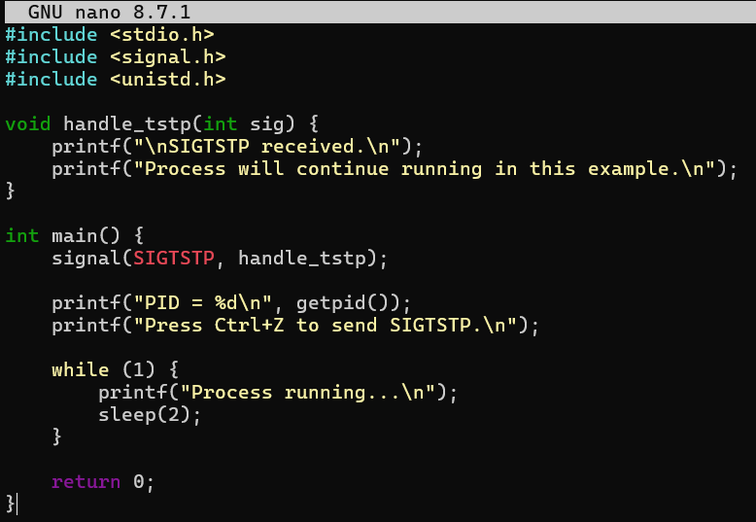
Output;
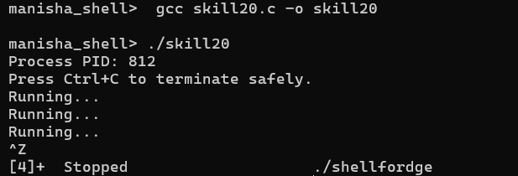

- To Connect Modules, Validate Interfaces, Test End-to-End Execution, Handle Errors, Improve Reliability, Refactor Components.
To Detect Runtime Errors, Generate Messages, Log Failures, Handle Invalid Syntax, Recover Gracefully, Test Error Scenarios.
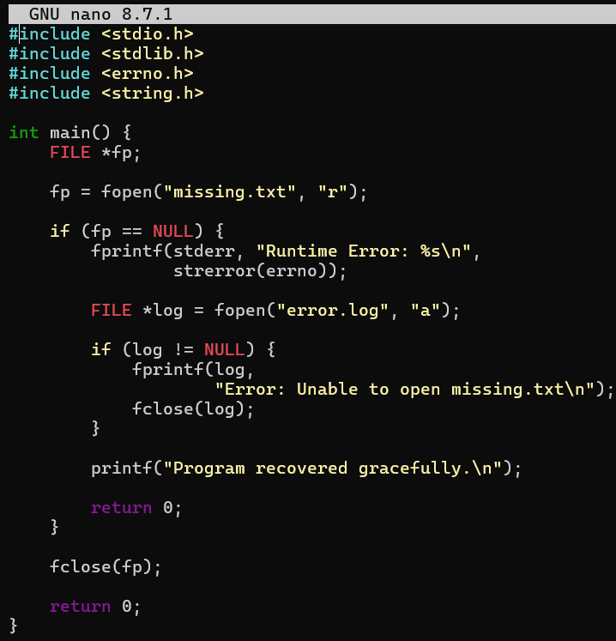
Output:
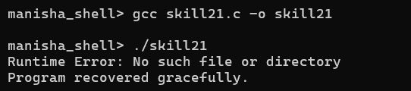

- To Run Valgrind, Identify Leaks, Fix Memory Errors, Release Resources, Verify Cleanup, Document Findings.
To Design Test Cases, Create Test Scripts, Automate Execution, Verify Outputs, Compare Results, Generate Reports.
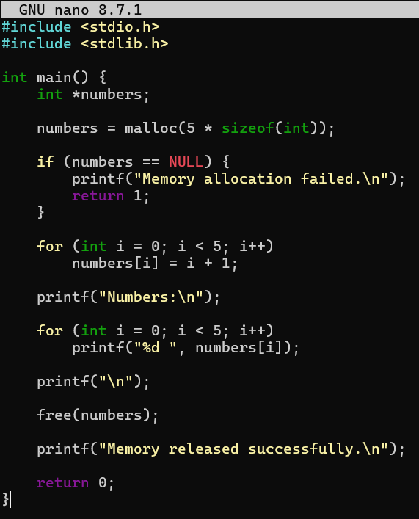
Output:
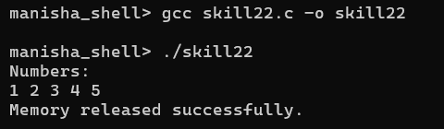

- To Execute Large Pipelines, Launch Multiple Jobs, Measure Stability, Monitor Resources, Detect Failures, Analyze Performance.
To Document Architecture, Create Flow Diagrams, Explain Execution Paths, Describe Syscalls, Record Design Decisions, Review Documentation.

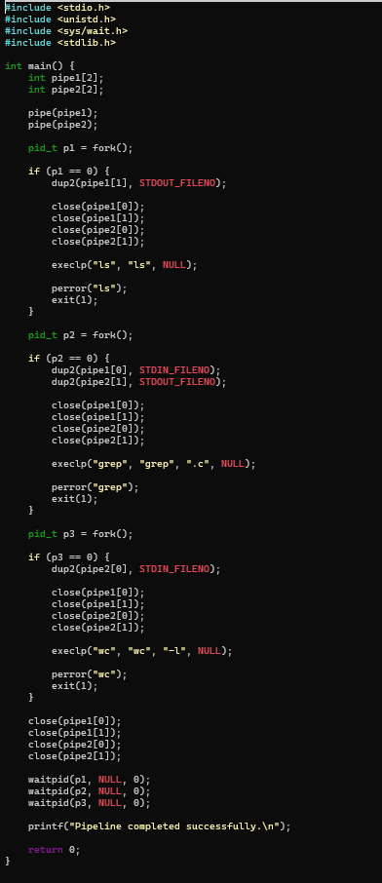

Output:
